Asia-China-Coin-18-Tartar Dynasties

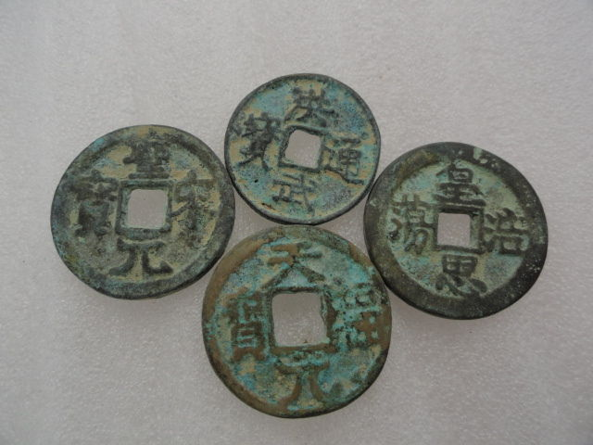

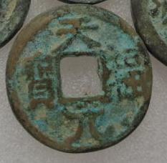 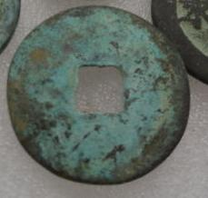

18.97 Tartar Dynasty-XiaEmperor Ren Zong (1139-1193)., Tian Sheng yuan bao

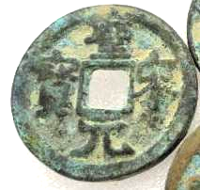 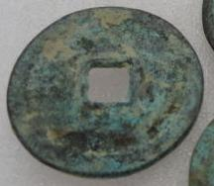

17.812

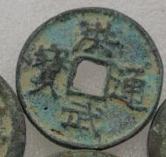 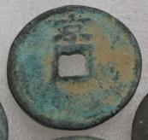

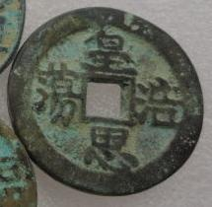 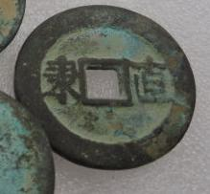

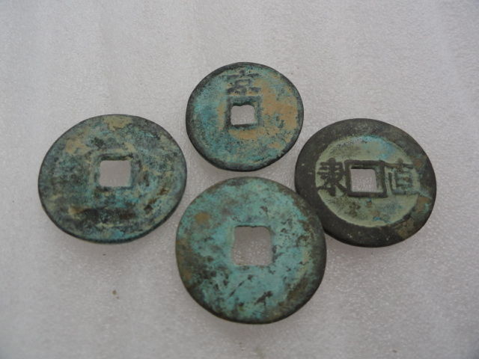

Order details Printer friendly page

Sold by

[lengxue](http://myworld.ebay.com/lengxue) ( [31](http://feedback.ebay.com/ws/eBayISAPI.dll?ViewFeedback&userid=lengxue)  )

+ Show additional actions

Delivery package 1 of 1

Estimated delivery Wednesday, Jan 15, 2014 - Friday, Jan 24, 2014

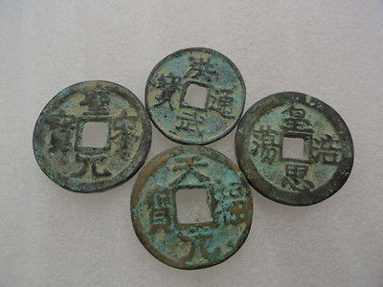

[Tools of the trade in ancient China, bronze sculpture, small,carved ancient font](http://www.ebay.com/itm/141149688017)

Item price

$0.99

Quantity

1

Item number

141149688017

Shipping service

ePacket delivery from China

[Leave feedback](http://feedback.ebay.com/ws/eBayISAPI.dll?LeaveFeedbackShow&useridfrom=802-867&useridto=lengxue&item=141149688017&transactid=0) [Contact seller](http://contact.ebay.com/ws/eBayISAPI.dll?FindAnswers&frm=3998&iid=141149688017&redirect=0&requested=lengxue) [Return item](http://return.ebay.com/ws/eBayISAPI.dll?ResolveReturn&eventName=viewSelectedItem&TransactionId=0&ItemId=141149688017)

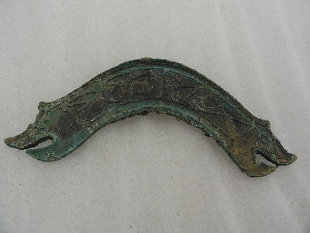

[Artwork Chinese bronze sculpture, bridge, carved tools of the trade,rusty，A+++](http://www.ebay.com/itm/141151168251)

Item price

$4.99

Quantity

1

Item number

141151168251

Shipping service

ePacket delivery from China

[Leave feedback](http://feedback.ebay.com/ws/eBayISAPI.dll?LeaveFeedbackShow&useridfrom=802-867&useridto=lengxue&item=141151168251&transactid=0) [Contact seller](http://contact.ebay.com/ws/eBayISAPI.dll?FindAnswers&frm=3998&iid=141151168251&redirect=0&requested=lengxue) [Return item](http://return.ebay.com/ws/eBayISAPI.dll?ResolveReturn&eventName=viewSelectedItem&TransactionId=0&ItemId=141151168251)

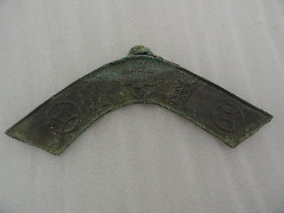

[Artwork Chinese bronze sculpture,large bridge, carved tools of the trade,rusty](http://www.ebay.com/itm/141151169441)

Item price

$5.99

Quantity

1

Item number

141151169441

Shipping service

ePacket delivery from China

[Leave feedback](http://feedback.ebay.com/ws/eBayISAPI.dll?LeaveFeedbackShow&useridfrom=802-867&useridto=lengxue&item=141151169441&transactid=0) [Contact seller](http://contact.ebay.com/ws/eBayISAPI.dll?FindAnswers&frm=3998&iid=141151169441&redirect=0&requested=lengxue) [Return item](http://return.ebay.com/ws/eBayISAPI.dll?ResolveReturn&eventName=viewSelectedItem&TransactionId=0&ItemId=141151169441)

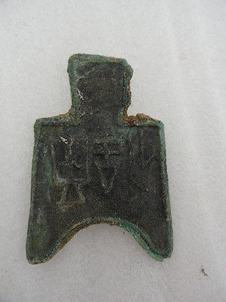

[Chinese bronze pattern tools of the trade ancient prose,sculpture,classical A+++](http://www.ebay.com/itm/141151170651)

Item price

$0.99

Quantity

1

Item number

141151170651

Shipping service

ePacket delivery from China

[Leave feedback](http://feedback.ebay.com/ws/eBayISAPI.dll?LeaveFeedbackShow&useridfrom=802-867&useridto=lengxue&item=141151170651&transactid=0) [Contact seller](http://contact.ebay.com/ws/eBayISAPI.dll?FindAnswers&frm=3998&iid=141151170651&redirect=0&requested=lengxue) [Return item](http://return.ebay.com/ws/eBayISAPI.dll?ResolveReturn&eventName=viewSelectedItem&TransactionId=0&ItemId=141151170651)

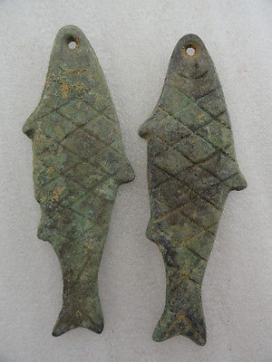

[Chinese bronze pendant,2 fishes sculpture,Tools of the trade,Carve decorative AA](http://www.ebay.com/itm/141151180078)

Item price

$6.99

Quantity

1

Item number

141151180078

Shipping service

ePacket delivery from China

[Leave feedback](http://feedback.ebay.com/ws/eBayISAPI.dll?LeaveFeedbackShow&useridfrom=802-867&useridto=lengxue&item=141151180078&transactid=0) [Contact seller](http://contact.ebay.com/ws/eBayISAPI.dll?FindAnswers&frm=3998&iid=141151180078&redirect=0&requested=lengxue) [Return item](http://return.ebay.com/ws/eBayISAPI.dll?ResolveReturn&eventName=viewSelectedItem&TransactionId=0&ItemId=141151180078)

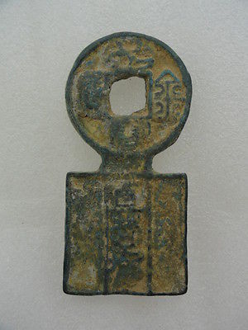

[Oriental Chinese bronze pattern tools of the trade ancient,sculpture,classical](http://www.ebay.com/itm/141151468812)

Item price

$3.99

Quantity

1

Item number

141151468812

Shipping service

ePacket delivery from China

[Leave feedback](http://feedback.ebay.com/ws/eBayISAPI.dll?LeaveFeedbackShow&useridfrom=802-867&useridto=lengxue&item=141151468812&transactid=0) [Contact seller](http://contact.ebay.com/ws/eBayISAPI.dll?FindAnswers&frm=3998&iid=141151468812&redirect=0&requested=lengxue) [Return item](http://return.ebay.com/ws/eBayISAPI.dll?ResolveReturn&eventName=viewSelectedItem&TransactionId=0&ItemId=141151468812)